PART I: PRE-LAB
Complete these questions before lab. To answer them correctly, you will need to read through the lab handout carefully. Be prepared to discuss the answers at the beginning of lab.

- What are the different alleles that you will examine? What is the function of these genes?
- How can you distinguish a fly that is homozygous for the Bar¹ mutation from a fly that is heterozygous or hemizygous for Bar¹?
- What is being tested in a chi square analysis?

Concepts to understand before beginning lab:
- How an organism’s genotype influences its phenotype
- Modes of inheritance: simple dominance, incomplete dominance, sex-linked
- Definitions of heterozygous vs. homozygous vs. hemizygous
- Interpretation of chi square analysis to determine if phenotypic ratios in offspring are as expected.

Goals:
- Distinguish between male and female D. melanogaster
- Distinguish between heterozygous/hemizygous and homozygous mutants based on phenotype
- Count flies and perform a chi square analysis to determine if Mendelian ratios are maintained in this population
- Propose explanations for deviations from Mendelian ratios

PART II: BACKGROUND INFORMATION

Introduction to Drosophila melanogaster
The fruit fly Drosophila melanogaster is a very useful organism for genetic research. In fact, it has probably been used more than any other model organism to define fundamental genetic principles. Thomas Hunt Morgan first described linked genes in 1910 by observing patterns of the white-eye mutation in male and female D. melanogaster. These studies also provided the first solid evidence that the chromosomes are the carriers of the genetic information.

Drosophila have many advantages that make it such a widely used model organism. For example, flies are simple to maintain, have a short generation time, and produce many offspring. Over the ~100 years that biologists have been studying Drosophila, 1000s of mutations have been found and located on their respective genes and chromosomes. In addition the Drosophila genome has been completely sequenced, allowing in depth analysis of individual genes. Flies only have 4 chromosomes: X/Y, 2nd, 3rd, and 4th. Amazingly, these 4 chromosomes contain homologous genes to 75% of disease-related genes in humans.

The life cycle of D. melanogaster consists of four stages: embryo, larva, pupa, and adult (Figure 1). The life cycle starts with the embryo, which hatches into a larva at about 24 hours post fertilization. The larval stage is devoted to feeding and growing. Drosophila larvae go through three growth stages called instars. The first and second instar last about 1 day each. The third instar lasts 2-3 days and is also called the wandering stage because the larvae crawl out of the food to find a dry surface on which to pupate. The pupal stage lasts 4-5 days and is when metamorphosis occurs. During this time, most larval tissues and organs are histolyzed (broken down) and the adult structures develop. When adults first emerge from their pupal cases, they are known as imagos, which are white and slender. Within a few hours of emergence, the adults’ pigment becomes darker and their bodies start to fill out. They reach sexual maturity within 6-8 hours of emergence. When flies are grown at 25ºC (77.7ºF), it takes about 10 days for an embryo to go through all of the developmental stages and emerge as an adult.
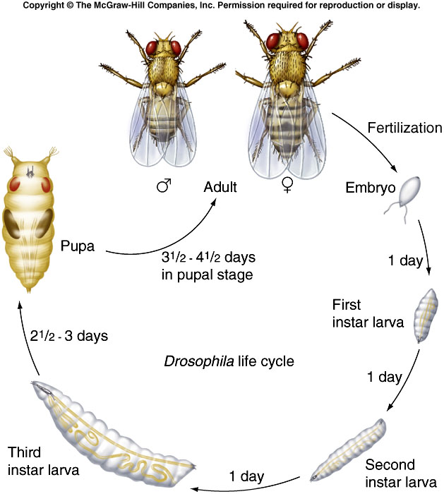

Figure 1: Life cycle of Drosophila at 25C.
Identifying adult male and female Drosophila
There are several physical differences between male and female flies to help you identify them. Females are generally larger with a larger abdomen (last body segment). Males are smaller with a more tapered abdomen (Figure 2). Males also have dark pigment on the last two segments of their abdomens.

The most accurate way to distinguish male and female flies is to flip the fly onto its back and look at the tip of the abdomen. Males will have a protruding anal plate that looks like a disc, while females do not (Figure 2).
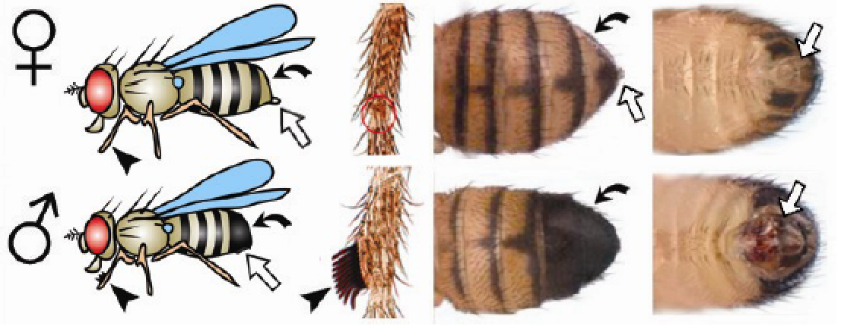
Figure 2: Distinguishing between male and female Drosophila (Prokop, 2012). ♀ is the symbol for female and ♂ is the symbol for male.

Identifying genetic mutations in Drosophila
The phenotype of an individual is controlled by the individuals’ genotype. Genes usually encode proteins that perform most of the work of the cells that make up the individual. These genes may code for proteins that are visible, such as the white gene, which codes for red eye pigment. Many genes in Drosophila are named after their mutant phenotype. White is a dominant allele, so this means that a fly with a wild type allele of white has red eyes, while a fly with two mutant alleles of white has white eyes.

One of the main mutant alleles we will examine in this lab is for the Bar gene. Bar is X-linked and shows incomplete dominance. Females that are homozygous for Bar and hemizygous Bar males have eyes that are reduced to a slit or bar shape. Heterozygous females have a kidney- or heart-shaped eye (see Figure 1). Our Bar mutants also contain mutant alleles for the genes white, yellow (body color), and singed (bristle shape). Therefore, you would expect that flies that are homozygous or hemizygous for Bar¹, would also have white eyes, yellow bodies, and short, burnt-looking bristles on their thoraxes.
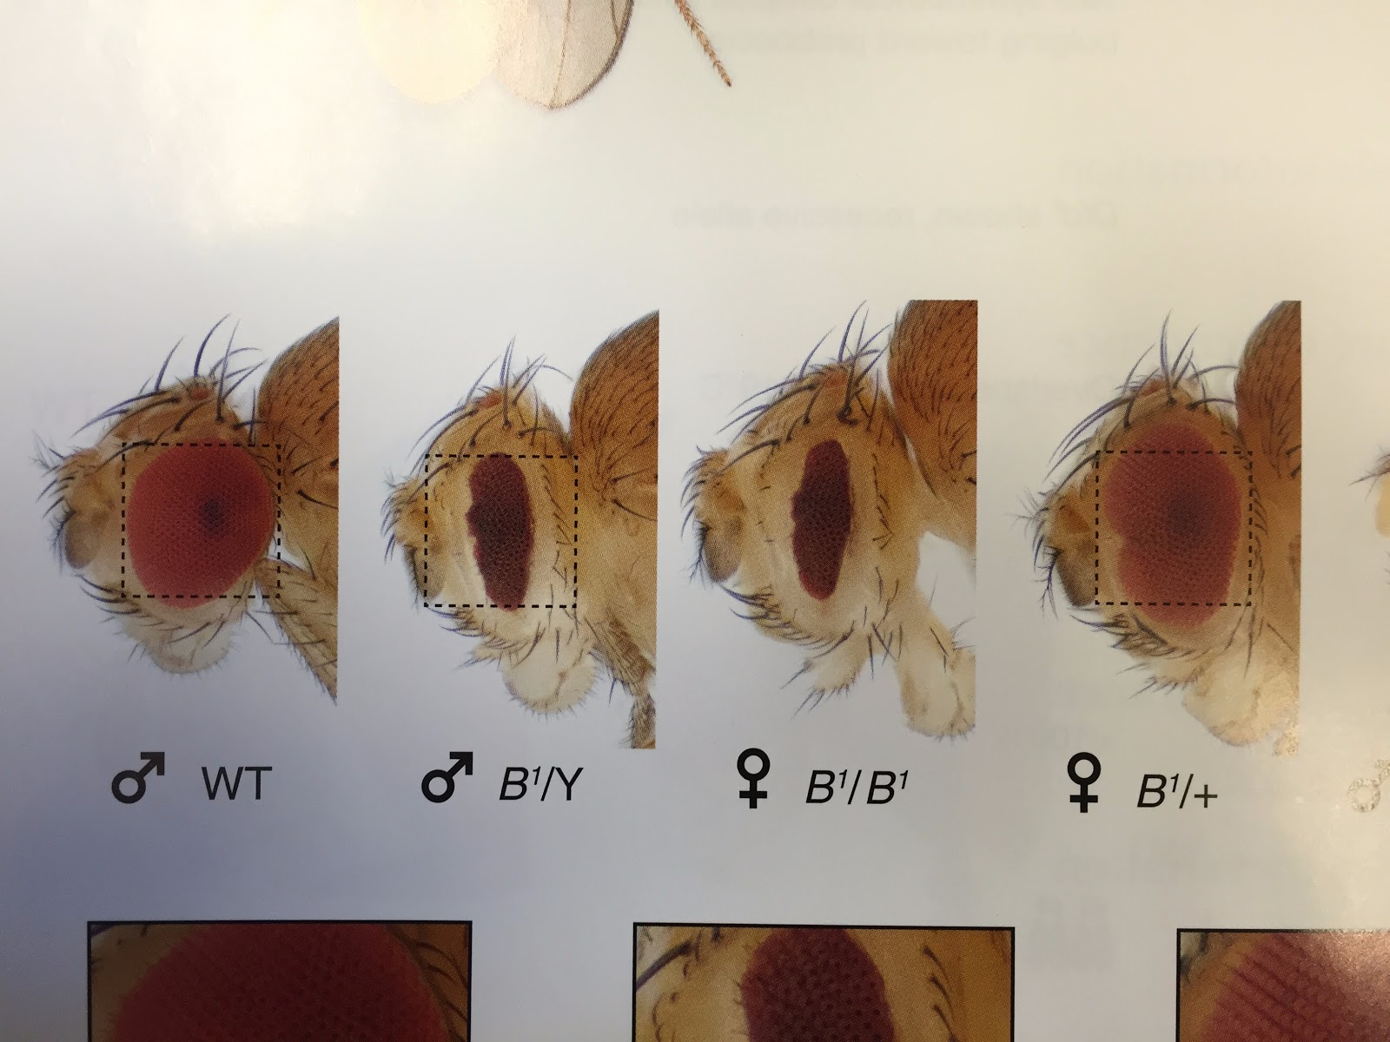
Figure 3. Comparison of three eye phenotypes/genotypes: left, wild-type round eye; middle, Bar male and bar female (slit-shaped eye); heterozygous kidney- or heart-shaped eye; right.
Our flies have a second mutation in the gene mus109, which is an X-linked gene involved in DNA repair (and the focus of our research projects this semester). Mus109 alleles have been shown to be recessive and sensitive to various DNA damaging reagents. The particular allele you are working with in this lab is called mus109^{ls}.
Parental cross and offspring predictions – answer these questions in your lab notebook
The following parental cross was set up for this lab:
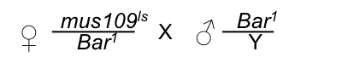
- What are the expected genotypes and phenotypes of the progeny?

- What percentage of the offspring do you expect to be each phenotypes? Make sure to differentiate males and females!

PART III: LAB ACTIVITY: DETERMINING MENDELIAN RATIOS OF MUS109/BAR MUTANTS

- Obtain a vial of wild type and mus109^{ls}/Bar¹ mutant Drosophila from your instructor (ask if you should have your own vial or if you should share with a partner).

- Anesthetize the wild type flies using Fly-nap:
  - Dip a wand into the fly nap and allow the excess liquid to drain off.
  - Insert the wand into your fly vial so that the wand is just below the stopper/cotton ball.
  - Place the vial on its side of 2-3 minutes, checking to make sure the flies are asleep by gently tapping the vial against the table.
  - As soon as the flies are asleep, transfer them to a 3x5 note card and view them under the microscope. The flies will usually stay asleep for 20 minutes.

- Draw male and female wild type flies in your lab notebook. Pay particular attention to the eyes and bristles on their dorsal thoraxes (backs). Make sure to properly label your drawings with figure numbers and descriptive captions.

- Anesthetize mus109^{ls}/Bar¹ flies using Fly-nap as described in step 2.

- Draw the Bar mutant phenotypes. Take notes on additional phenotypes observed alongside Bar, such as white eyes (w), yellow body (y), and singed bristles (sn). Make sure to properly label your drawings with figure numbers and descriptive captions.

- Draw a table in your notebook (like the table below) that represent your expected phenotypic classes.

Bar¹/Bar¹ females  (bar-shaped eyes) | mus109^{ls}/Bar¹ females (kidney-shaped eyes) | Bar¹/Y males  (bar-shaped eyes) | mus109^{ls}/Y males  (round eyes)

- Count flies. Make a tally mark in the correct part of your table for each fly.

PART IV: CHI SQUARE ANALYSIS
A chi square statistical test analyzes the difference between expected and actual outcomes. You can use the chi square test to show if there is a significant difference between the phenotypic ratios that you obtained in this experiment compared to the expected Mendelian ratios. You can then determine the probability that the differences in populations are due to random chance (p-value) using the following table:

p-values:
df .990 .950 .900 .750 .500 .250 .100 .050 .025 .010 .005
1 .000157 .00393 .0158 .102 .455 1.32 2.71 3.84 5.02 6.63 7.78
2 .0201 .103 .211 .575 1.39 2.77 4.61 5.99 7.38 9.21 10.6
3 .115 .352 .584 1.21 2.37 4.11 6.25 7.81 9.35 11.3 12.8
4 .297 .711 1.06 1.92 3.36 5.39 7.78 9.49 11.1 13.3 14.9
5 .554 1.15 1.61 2.67 4.35 6.63 9.24 11.1 12.8 15.1 16.7

What is your null hypothesis for this Chi square analysis?

Copy the following table into your notebook and fill out the information to calculate your chi square value.
Phenotype | Observed | Expected | O-E (deviation) | (O-E)² | (O-E)²/E
Bar¹/Bar¹ females
(bar eyes)
mus109^{ls}/Bar¹ females
(kidney eyes)
Bar¹/Y males
(bar eyes)
mus109^{ls}/Y males
(round eyes)
Total |  |  | ----------------- | ---------------

In your notebook, answer the following questions.

The degrees of freedom are __________________________.

The p-value is between _________ and ___________.

Is there a significant difference between your observed and expected populations of flies? How do you know?

PART V: DISCUSSION QUESTIONS
Answer the following questions in your lab notebook.
- Based on your chi square analysis, what can you conclude about the phenotypic ratios observed in your fly cross?

- If you did observe a significant difference in ratios, propose a genetic explanation for your observations. Your answer should include an explanation for mode of inheritance for both Bar¹ and mus109^{ls}. Use your chapter 4 notes to help guide your answer.

